
Student Number
Mark / 100

2009

TRIAL HSC ANSWERS
EXAMINATION

Chemistry

General Instructions

•Reading time – 5 minutes
•Working time – 3 hours
•Write using black or blue pen
• Draw diagrams using pencil
•Write your Student Number at the top of this page and on the response sheets on pages ...
•Board-approved calculators may be used
•A data sheet and a Periodic Table are provided at
the back of this paper. This may be removed for your
convenience.
•Write your Student Number at the top of this page
and those of .....

Total Marks – 100

Section I Pages....

75 marks

This section has two parts, Part A and Part B

Part A – marks
•Attempt Questions 1-
•Allow about 30 minutes for this part

Part B – 60 marks
•Attempt Questions .........
•Allow about 1 hour and 45 minutes for this
part

Section II Pages ......

25 marks

•Attempt Question.
•Allow about 45 minutes for this section
Confidential
Keep Secure

Section I
75 marks

Part A – 15 marks
Attempt Questions 1-15
Allow about 30 minutes for this part

Use the multiple choice answer sheet on page .....
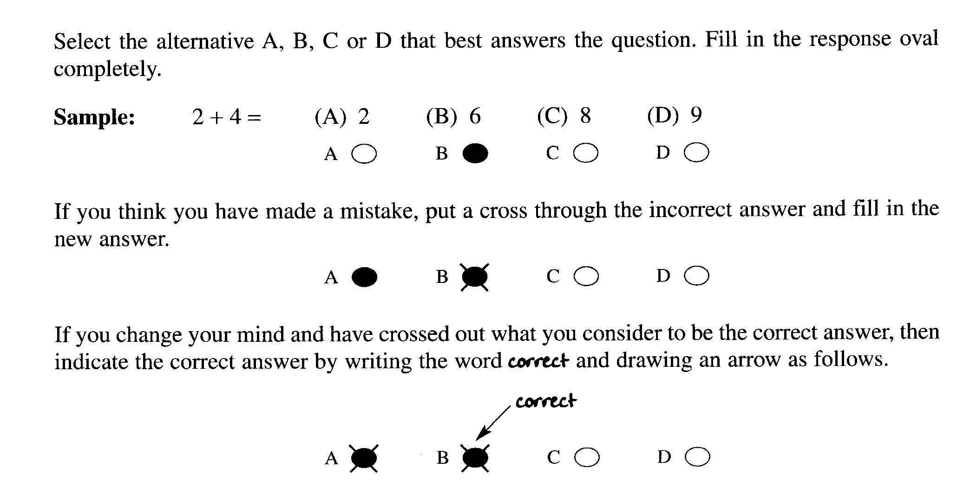

Mark your answers on the ANSWER grid on page.............
________________________________________________________________________________

1. Which of the statements below describes a transuranic element ?

(A) Elements transformed during nuclear reactions.

(B) Elements with atomic number more than 91.

(C) Elements with atomic number less than 92.

(D) Elements that undergo radioactive decay.

2. The table below shows information about a variety of indicators.

Indicator | Colour in low pH | Colour in high pH | pH range
Methyl orange | Red | Yellow | 3.1 - 4.4
Bromophenol blue | Yellow | Blue | 3.0 - 4.6
Methyl red | Pink | Yellow | 4.4 - 6.0
Phenol red | yellow | red | 6.8 - 8.4

Which two indicators could be best used to identify rain with a pH of approximately 6.2 ?

(A) methyl orange and bromophenol blue

(B) methyl red and phenol red

(C) methyl orange and methyl red

(D) methyl red and bromophenol blue

3. Which equation best represents catalytic cracking of a petroleum fraction?

(A) C₁₆H₃₄(l) 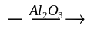C₁₆H₃₄(g)

(B) nC₂H₄(g) → (CH₂—CH₂ )_{n} (s)

(C) C₁₆H₃₄(l) C₇H₁₆(l)   + 3C₂H₄(g) +  C₃H₆(g)

(D) C₇H₁₆(l) + 3 C₂H₄(g) +  C₃H₆(g) C₁₆H₃₄(l)

4. Why is research into synthetic biopolymers attracting great interest ?

(A) Synthetic biopolymers decompose more easily than traditional synthetic
polymers.

(B) Synthetic biopolymers can be produced more cheaply than traditional synthetic
polymers.

(C) Synthetic biopolymers have superior physical properties compared to traditional
synthetic polymers.

(D) Synthetic biopolymers have superior chemical properties compared to traditional
synthetic polymers.

5. Refer to the modified periodic table below to answer this question
The table provides information about the Groups to which each element
U, V, W, X, Y, Z belong

I | II |  | III | IV | V | VI | VII | Noble Gases
Y |  |  | V
 |  |  |  |  |  |  | Z
 |  | U
X
 |  |  |  |  |  |  | W

What are the reactions of oxides of these elements with acid and with base?

 | Oxides react with acids | Oxides react with base | Oxide reacts with acid and with base
(A) | Z | X | V
(B) | Y | X | U
(C) | X | Z | V
(D) | V | W | Y

6. Which condensed structural formula represents the ester formed from the reaction of propanoic acid with
1-heptanol?

(A) CH₃CH₂COOCH₂CH₂CH₂CH₂CH₂CH₂CH₃

(B) CH₃CH₂CH₂CH₂CH₂CH₂COOCH₂CH₃

(C) CH₃CH₂CH₂CH₂COOCH₂CH₂CH₂CH₂CH₃

(D) CH₃CH₂CH₂CH₂CH₂CH₂OCH₂CH₂COOH

The following information refers to questions 7 and 8

Calcium carbonate decomposes to form calcium oxide and carbon dioxide according to the
following equilibrium reaction. This reaction is endothermic.

CaCO₃(s) 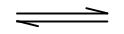 CaO(s) + CO₂(g)

7.. What mass of calcium carbonate is needed to form 5.00 L of carbon dioxide at 25ºC and 100 kPa?

(A) 1.238 g

(B) 10.51 g

(C) 20.19 g

- 22.04 g

8. What would happen if the reaction at equilibrium suddenly has its volume decreased?

(A) The reaction shifts to the right, favouring the formation of CaO.

(B) The reaction shifts to the right, favouring the formation of CO₂.

(C) The reaction shifts to the left, favouring the formation of CaCO₃.

- The reaction shifts to the left, favouring the formation of CO₂.

9. Which conditions would promote the greatest increase in the pH of an aqueous
solution of carbon dioxide?

(A) Addition of CO₂ and cooling.

(B) Addition of H₂O and heating.

(C) Addition of carbonic acid.

(D) Cooling the reaction.

10. Which chemical would have the highest boiling point?

(A) butane

(B) propanoic acid

(C) 1-butanol

(D) butanoic acid

11 Given the following reaction:

HClO₄ + CH₃COOH CH₃COOH₂⁺ + ClO₄⁻

Which species are acting as Bronsted-Lowry acids in this reaction?

(A) HClO₄ and ClO₄⁻

(B) CH₃COOH and HClO₄

(C) HClO₄ and CH₃COOH₂⁺

(D) CH₃COOH and ClO₄⁻

Outcomes: H13

Outcome(s): H13,

12. Consider the following compounds:

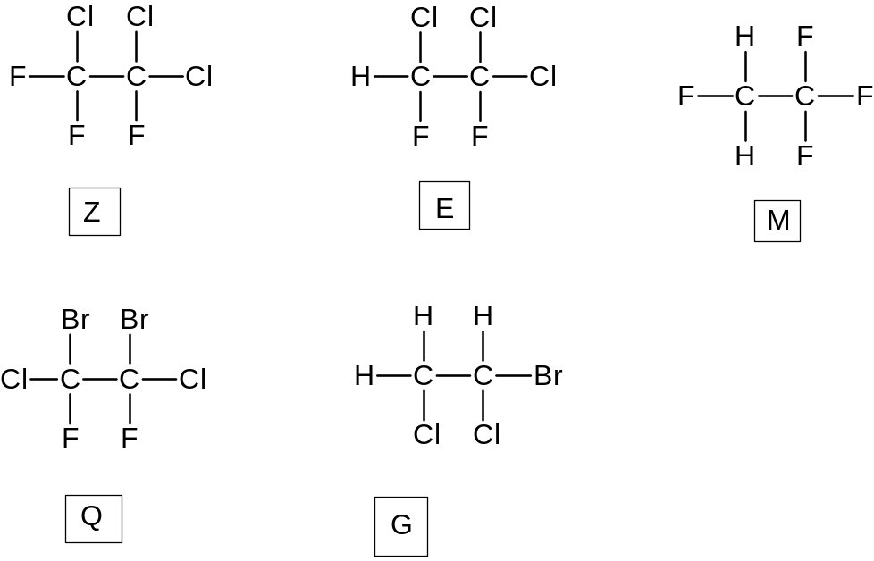

Choose the set which classifies Z, E, M, Q and G correctly

 | Z | E | M | Q | G
(A) | haloalkane | HFC | HCFC | halon | CFC
(B) | CFC | HFC | HCFC | haloalkane | halon
(C) | CFC | HCFC | HFC | halon | haloalkane
(D) | CFC | HCFC | halon | HFC | haloalkane

13. A water sample was found to have a pH of 1.2. Which ion is likely to be absent in the water
sample?

(A) chloride

(B) carbonate

(C) sulfate

(D) nitrate

14. Which quality of water is being tested by determining the percentage of light that is
transmitted or scattered, in the absence of added reagents, through a standard depth of
water?

(A) NTU

(B) TDS

(C) BOD

(D) Turbidity

15. Ginny, Hermione, Luna and Cho were each given different unknown solutions
containing only one cation. The unknown ions may be sodium, barium, iron and copper.

The students tested their solutions with sulfate, carbonate and chloride ions. Their results are
given in the table. Cho had a blue coloured solution. The others had colourless solutions.

Analyst | sulfate | carbonate | chloride
Ginny | precipitate | precipitate | no precipitate
Hermione | no precipitate | no precipitate | no precipitate
Luna | no precipitate | precipitate | no precipitate
Cho | no precipitate | precipitate | no precipitate

What ion did they each have?

 | Ginny | Hermione | Luna | Cho
(A) | barium | sodium | iron | copper
(B) | iron | sodium | barium | copper
(C) | sodium | barium | iron | copper
(D) | barium | iron | sodium | copper

Student Number …………………………

Section I Mark -----/15
Part A
Multiple Choice Answer Sheet

1. A  B  C  D 

2. A  B  C  D 

3. A  B  C  D 

4. A  B  C  D 

5. A  B  C  D 

6. A  B  C  D 

7. A  B  C  D 

8. A  B  C  D 

9. A  B  C  D 

10. A  B  C  D 

11. A  B  C  D 

12. A  B  C  D 

13 A  B  C  D 

14. A  B  C  D 

15. A  B  C  D 

Student No. ……………………….
Part B. 60 marks
Attempt questions ...................
Allow about 1 hour and 45 minutes for this part
Show all relevant working in questions involving calculations
MARKS

Question 16 (5 marks)

The table shows properties of some fuels.

FUEL | MAIN SOURCE | Heat of Combustion  (kJ g⁻¹) | Boiling Point  (⁰C)
Methane | Petrochemical industry | 55.6 | -161.5
Propane | Petrochemical industry  Natural Gas | 50.3 | -42.1
Octane | Refined from crude oil | 47.9 | 125.7
Ethanol | Hydration of ethane  Fermentation | 29.7 | 78.3

Assess the potential of ethanol as an alternative fuel. 5

Sample Answer :

Advantages of ethanol as an alternative fuel include that it is a renewable resource
when produced by fermentation of sugar from crops, burns completely in oxygen (cleaner
burning fuel).

C₆H₁₂O₆(aq) → 2CH₃CH₂OH(l) + 2CO₂(g)

CH₃CH₂OH(l) + 3 O₂(g) → 2CO₂(g) + 3 H₂O(l)

The other fuels in the table are non-renewable resources as they are produced from
petrochemicals and undergoes incomplete combustion thus producing toxic CO or carcinogenic
soot.

Disadvantages of ethanol include it can only be used as a 10-15% ethanol/petrol blend in cars
thus high engine modification is necessary. Large scale use of ethanol requires large land clearing
for crop growth

When advantages and disadvatages are weighed up ethanol still has potential as an alternative fuel.
The big advantage in lowering pollution is very important in the current environment and outweighs
the loss of crop land

Must have an assessment statement and must refer to relevant information in the Table eg heat of combustion of ethanol compared to other fuels( large amount must be burnt to provide enough energy as ethanol has low heat of combustion ; high B.P.thus safe to transport as a liquid etc)

Marking Criteria
Criteria | Marks
Assessment of ethanol as an alternative fuel using data from the table | 5
Assessment of ethanol as an alternative fuel without use of data from the table | 4
Discussion of use of ethanol as an alternative fuel ( advantages and disadvantages | 3
Outline of use of ethanol as an alternative fuel. | 2
Identifies ONE advantage or disadvantage of the use of ethanol as an alternative fuel | 1

Question 17 (4 marks)

You have studied one of the cells : (i) The Dry Cell Battery (ii) The Lead Acid Battery

(a) State ONE environmental impact associated with the cell you have chosen. 1

Sample Answer:
Dry cell disposed in landfill site may lead to zinc case corroding and excessive ions leaching into soil which is toxic to vegetation.

Marking criteria
Criteria | Mark
Correct statement about one environmental impact of the cell | 1

(b) Describe the chemistry of the cell you have chosen. 3

Sample Answer :

In the dry cell consists of a graphite electrode inserted into a moist paste NH₄Cl, ZnCl₂ and MnO₂
electrolyte in zinc anode case.

The zinc anode oxidizes : Zn → Zn²⁺ + 2e⁻

At the graphite cathode : 2NH₄⁺(aq) + 2e- → 2NH₃(g) + H₂(g)

Manganese(IV) oxide is an oxidizing agent which converts the hydrogen gas to water

2MnO₂(s) + H₂(g) → Mn₂O₃(s) + H₂O(l)

The ammonia gas reacts with the Zn²⁺ ion

Zn²⁺⁽aq) + 2NH3(g) + 2Cl⁻(aq) → Zn(NH₃)₂Cl₂(s)

The reactions have a net potential of 1.5V

Marking Criteria
Criteria | Mark
Correct description of cell chemistry including anode and cathode reactions with correct half equations and electrolyte | 3
Correct description of cell chemistry with only one half equation and electrolyte | 2
Identification of anode or cathode in the cell | 1

Question 18 (7marks)

(a) Draw, in the space below, a scientifically labeled diagram of the following galvanic cell
in operation : . 3

Ni / Ni²⁺ and Ag⁺ / Ag

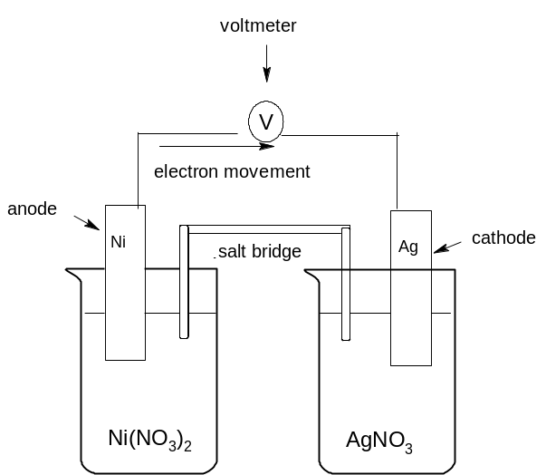

Marking Criteria
Criteria | Mark
Correct 2-D, labeled diagram showing anode, cathode, salt bridge, voltmeter and correct direction of flow of electrons | 3
Any one of the above not present | 2
Any two of the above not present | 1

(b) Write the anode half-equation for the above galvanic cell 1

........................................................................................................................................................

Answer :

Ni → Ni²⁺ + 2e_

Marking criteria
Criteria | Mark
Correct anode half-equation | 1

(c) Write the cathode half-equation for the above galvanic cell 1

.
Answer :

Ag⁺ + e⁻ → Ag(s)

Marking Criteria
Criteria | Mark
Correct cathode half-equation | 1

(d) Use the standard reduction potential table to calculate the E⁰ potential of the above
galvanic cell. Show all working 2

Answer:

E⁰ = 0.80 + 0.24 = 1.04V

Marking criteria
Criteria | Mark
Correct calculation of E⁰ showing all working | 2
Correct working but incorrect answer or correct answer but incorrect working | 1

Question 19 (5 marks)

A student carried out a first-hand investigation to determine the heat of combustion of ethanol
using a spirit-burner. The student heated 200 mL of water in a beaker for 3 minutes and recorded
results of the investigation in the table below :

Initial mass of burner | 213.27 g
Final mass of burner | 212.58 g
Mass of fuel used | 0.69 g
Mass of water heated | 200 g
Initial temperature of water | 18.00 ºC
Final temperature of water | 40.00 ºC

(a) Write a balanced equation for the combustion of ethanol including states. 1

Answer :

C₂H₅OH(l) + 3O₂(g) → 2CO₂(g) + 3H₂O(l)

Marking Criteria
Criteria | Mark
Correct balanced equation with states | 1

(b) Calculate the molar heat of combustion of ethanol. 3

Answer

h = - m C∆T = - 200 X 4.2 X 22 = - 18.48 kJ 1

∆H = -h / ( m/M) = -18.48 / (0.69 / 46) = -1246 kJ mol-1 1

Marking criteria
Criteria | Mark
Correct calculation of molar heat of combustion of ethanol showing all working | 3
Correct calculation of heat of combustion of 0.69g ethanol ; 2 correct calculations | 2
One correct calculation in the process showing one correct answer | 1

(c) Suggest a reason why the experimental value is less than the theoretical ∆H value
of -1364 kJmol⁻¹ 1

Answer :

The beaker was made of glass and lost heat to the surroundings or combustion
was incomplete.

Marking criteria
Criteria | Mark
One correct reason for the above | 1

Question 20 (3 marks)

Explain why alkanes and their corresponding alkenes have similar physical properties,
but very different chemical properties. 3

Sample Answer

Alkanes and corresponding alkenes are non-polar molecules with dispersion forces between the
molecules thus have similar physical properties eg low M.P. and solubility.

Chemical properties are due to bonding within the molecules and alkenes have at least one
reactive double bond whilst alkanes have unreactive single bonds within the molecule.

Marking Criteria
Criteria | Mark
Explains the similarities in physical properties and differences in chemical properties in alkanes and alkenes due to the similar intermolecular forces and and different bonds between carbon atoms in alkanes and alkenes (dispersion forces, non-polar molecules, same number of carbon and similar number of H atoms in corresponding alkanea and alkenes BUT alkenes have a reactive double bond | 3
Describes similarities and differences in properties between alkanes and alkenes. | 2
Identifies properties in alkanes and alkenes | 1

Question 21 (3 marks)

Explain the differences in pH values that would be observed for 0.05 molL⁻¹ solutions of
acetic, citric and hydrochloric acids. 3

Sample Answer

Hydrochloric acid would have the lowest pH. Acetic acid would have the highest pH. HCl (aq) is a strong acid, ionising completely in aqueous solution. Citric acid is triprotic weak acid that furnishes more H⁺ than acetic acid since (a) its first ionisation is larger than that of acetic acid, and (b) it has three ionisation events whereas acetic acid only has one.

Outcome criteria | Marks
Correctly ranks the three acids on the basis of estimated pH.  States that HCl is 100% ionised.  Provides one reason for citric acid being slightly more ionised than acetic acid. | 3
Correctly ranks the three acids on the basis of estimated pH.  States that HCl is 100% ionised. | 2
Correctly ranks the three acids on the basis of estimated pH. | 1

Question 22 (2 marks)

(a) Calculate the pH of a 0.25 molL⁻¹ solution of nitric acid. 1

Answer (a) pH = (1)

(b) Describe the effect on the pH if the nitric acid is diluted with demineralised water. 1

Answer (b) pH would increase. (1)

Question 23 (5 marks)

(a) State one industrial source of oxides of sulfur. 1

Possible Answer

Metal smelters and power stations. (1)

(b) Write a chemical equation to show the formation of one type of oxide of nitrogen. 1

Possible Answer

N₂(g) + O₂(g) → 2NO(g) (1)

- Explain the concern about the release of oxides of nitrogen into the environment. 2

Possible Answer

Oxides of nitrogen may react with water to form acid rain. Acid rain can affect the environment b damaging vegetation and decreasing fish populations in lakes. NO₂(g) may contribute to the formation of ozone in the troposphere. Ozone is poisonous to plants and animals.

Outcome criteria | Marks
Explains the environmental effect of oxides of nitrogen. | 2
Recognises one environmental effect of oxides of sulfur or nitrogen. | 1

(d) Describe how you would assess the validity of the information gathered about the atmospheric
concentrations of oxides of sulfur and nitrogen. 1

Possible Answer

Determine the credibility of the information source. If the information is from university-based
sources than the information is more valid than information obtained elsewhere. (1)

Question 24 (8 marks)

Anna Lizt is a technology-oriented student of Esur Semaj High School. Anna wanted to analyse the
acid content of a certain diprotic food acid (H₂A) using two titration techniques for endpoint determination:
the indicator method and the pH probe method.

Table 1 outlines the steps of the analysis Anna followed. Table 2 gives the results of the analysis.

TABLE 1
Step | Indicator method | pH probe method
1 | 5.214 g of a solid monoprotic primary standard acid (MW = 204.22 g mol⁻¹) weighed, dissolved and diluted to 250.00 mL in a 250-mL volumetric flask.
2 | 25.00 mL aliquot of the acid is pipetted into a 250-mL conical flask | 25.00 mL aliquot of the acid is pipetted into a 250-mL beaker
3 | two drops of phenolpthalein added to the flask | a magnetic stirring bar and a pH probe (connected to a data logger) are inserted into the beaker.
4 | burette is filled with NaOH solution | burette is filled with NaOH solution, the magnetic stirrer turned on and the data logger activated
5 | NaOH solution added dropwise until the colourless solution turns light pink | NaOH solution added incrementally and the pH monitored after each addition. A graph of pH against volume of added NaOH solution exhibits an S shaped curve
6 | 25.00 mL of food acid is diluted to 250.00 mL in a volumetric flask
7 | Steps 1-5 repeated 3 times
8 | Steps 1-5 done 4 times substituting food acid (H₂A) solution instead of the standard acid solution  An average titre of 38.45 mL was obtained for the pH probe technique

TABLE 2
Standardisation NaOH
Trial | Titre (mL)
Trial | Indicator method | pH probe
1 | 22.51 | 22.48 |  | 22.34
2 | 22.31 | 22.28 | 22.30 | 22.34
3 | 22.37 | 22.30 | 22.30 | 22.34
4 | 22.28 | 22.32 | 22.30 | 22.34

(a) What rinsing protocol is required for step 2 in the indicator method given in Table 1? 1

Answer:
The pipette must be rinsed with the standard acid solution or the conical flask rinsed with
demineralised water.

Outcome criteria | Marks
Either of the two given answers will earn the mark | 1

(b) Explain the need to standardise the NaOH with a primary standard solution instead of
just preparing a standard solution of NaOH by weighing. solid NaOH. 1

Answer:

NaOH is unsuitable as a primary standard because it is hygroscopic, it absorbs water from
the atmosphere.

(c) Calculate the concentration of the standard acid solution in mol L⁻¹ 1

Answer

C_{standard acid} = 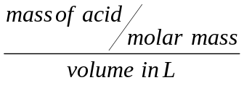 = 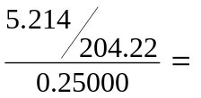0.1021 mol L⁻¹ (1 mark)

(d) Calculate the concentration of the NaOH solution.using the pH probe method. 1

Possible Answer:

moles NaOH = moles standard acid

C_{NaOH} = 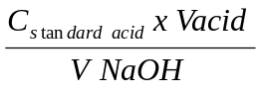= 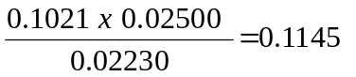 (1 mark)

(e) Calculate the concentration (in mol L⁻¹ ) of the diprotic food acid (H₂A) using the
pH probe technique. 2

Answer:

H₂A(aq) + 2 NaOH (aq) → Na₂A (aq) + 2 H₂O (l)

moles H₂A = 1/2 moles NaOH (1 mark)

C (H₂A) =

(1 mark)

The acid was diluted 1:10, therefore the actual concentration is 0.8805 mol L⁻¹

(f) Which of the techniques gave more reliable results for the standardization of the
NaOH?. Explain a possible reason for this. 2

Answer

The pH probe technique gave a more reliable answer since the precision is better.
The better precision could be due to the more objective judgementt of the endpoint as it
did not depend on individual perception of colour

Outcome criteria | Marks
choice of pH probe giving the criterion for the judgement | 1
reason for the better reliability | 1

Outcome(s): H10, H11,H12, H13, H14

Question 25 (3 marks)

Justify the need for monitoring combustion reactions. Use balanced formula equations to
support your answer. 3

Answer:

Combustion reactions need to be monitored to ensure complete combustion. Incomplete
combustion releases less heat energy and produce CO and C particulates which are toxic pollutants

Eqn 1: CH₄ (g) + 2 O₂(g) → CO₂ (g) + 2 H₂O

Eqn:2: CH₄ (g) + 3/2 O₂(g) → CO (g) + 2 H₂O

Outcome criteria | Marks
two reasons for the need to monitor and one equations | 3
one reason for the need to monitor and two equations | 3
one reason for the need to monitor and one equation | 2
one or two equations only | 1
one or two reasons and no equation | 1
Outcome(s): H11,H9

Question 26 (5 marks)

Mercurio Krum is a very inquisitive high school student. Mercurio suspected that his home’s
water supply has an unusually high level of copper ions from the household’s copper water pipes as
the water tasted awful..
He therefore asked his university friend to help him do an AAS analysis of the water samples from
his home.

- He took early morning water samples for five consecutive days.
- He pipetted 50.00 mL of his water sample into a 100.00 mL volumetric flask and then
diluted it to the mark. He did this for all his samples
- He also prepared six standard copper solutions

The complete result of the analysis are tabulated in the table:

Sample | ppm Cu²⁺ | Absorbance
Standard 1 | 0.21 | 0.102
Standard 2 | 0.32 | 0.203
Standard 3 | 0.42 | 0.300
Standard 4 | 0.52 | 0.401
Standard 5 | 0.61 | 0.502
Standard 6 | 0.71 | 0.601
water sample | unknown | Ave 0.557

(a) Use the grid below to prepare a labeled calibration curve of the results. 2

Possible Answer
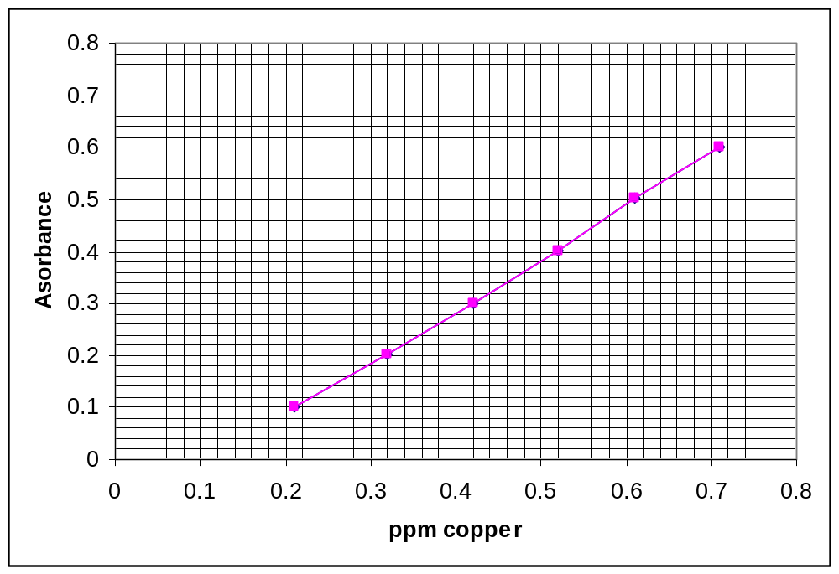

Outcome criteria | Marks
Axes labeled correctly with correct units | 1
Data points plotted correctly and line of best fit | 1

(b) Use your graph to determine the concentration of the water sample in ppm as obtained
from the experiment. 1

Answer
: 0.66 ppm from the graph (1 mark )

(c) Calculate the Cu²⁺ concentration of the undiluted water sample in molL⁻¹ 1

Answer:

From the graph, the concentration of Cu²⁺ in the morning sample is 0.66 ppm

∴original sample is 0.66 x 2 (dilution factor) = 1.32 ppm

C in mol L⁻¹ =
(1 mark)

(d) Mercurio consulted the internet and found that the Cu²⁺ concentration in drinking water to be
safe for drinking must not exceed 1300 μg L⁻¹ ( 10⁻⁶g = 1 microgram (μg)). Should
Mercurio recommend to his parents to replace the old water pipes with new ones?
Justify your answer. 1

Answer

The cut-off value of Cu²⁺concentration for safe drinking water (1.3 ppm) is exceeded by the results of his analysis (1.32 ppm) He must recommend to his parents to change the water pipe.

Outcome(s): H10, H11,H12, H13, H14

Question 27 (4 marks)

Explain in terms of structure and/or bonding the following characteristics of ozone and oxygen:

(a) Ozone is more reactive than oxygen: (2 marks)

Possible answer:

Ozone is more reactive than oxygen because of its bonding (1 mark). The oxygen atoms
in the oxygen molecule are double bonded to each other while the oxygens in ozone is
singly bonded and double bonded. The single bonded oxygen is easier to break and hence ozone is more
reactive.

Alternative answer: Oxygen has a bond order of 2 whereas ozone has a bond order of 1.5 (considering
the resonance structures). It is therefore, easier to break the bond(s) in ozone. This makes ozone more
reactive.

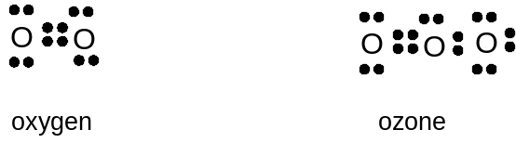

Outcome(s): H13

(b) Ozone has a higher boiling point than oxygen (2 marks)

Possible Answer

The higher boiling point of ozone is due to the difference in structure
between ozone and oxygen (1 mark). The ozone molecule is bent and, therefore has a higher dipole moment, that is, it is more polar than the oxygen molecule. Greater polarity means greater intermolecular forces and hence higher boiling point. (1 mark)

Question 28 (6 marks)

Describe and assess the effectiveness of methods to used to sanitise mass water supply. 6

Possible Answer:

Chlorination and ozonation are the two main methods by which mass water supply is sanitised.
Chlorination involves the introduction of Cl₂ gas into the water. The water reacts with the chlorine
producing HOCl. The HOCl kills bacteria as it readily passes through their cell membrane.
Advantages: Chlorine (active form - HOCl) is effective, relatively inexpensive and provides residual protection for stored water.
Disadvantages: However, it is not effective for some organisms such as viruses and protozoans and is not stable in concentrated form, so it cannot be stored.

Ozonation: Ozone is produced with an electrical discharge (20,000 volts) in dry air. The resulting ozone laden air is bubbled through water.

Disadvantages: Ozone can react with organic materials present in the water converting them to toxic forms
There is no residual protection in the purified water against future contamination. It is also
very expensive to administer.

Advantages: Ozone is more effective in killing waterborne viruses than hypochlorous acid . It is also
effective against viruses whereas chlorine has no effect at all

Judgement: Treatment of mass water supply is a balance between cost and effectiveness. Ozone sterilization can remove most microorganism but it has disadvantages and at a cost. The present lower cost method of water treatment has worked since the protozoan scare of 1998 because of better catchment management and hence must be retained.

Outcome criteria | Marks
Description of chlorination and ozonation | 1
Advantages and disadvantages of each technique | 4
Judgement about which is the more suitable sanitizer for mass water supply | 1

Outcome(s):, H13, H14, H4

2009 TRIAL HIGHER SCHOOL CERTIFICATE EXAMINATION

CHEMISTRY

Section II

Question 29: Industrial Chemistry

25 marks
Allow about 45 minutes for this section

Answer the questions in a writing booklet. Extra writing booklets are available.
Show all relevant working in questions involving calculations.

Marks
(a) The table shows the effect of temperature on the equilibrium constant (K)
for the Contact Process.

2SO₂ (g) + O₂ (g) 2SO₃ (g)

Temperature ⁰C | K
700 | 2.63
800 | 0.915
900 | 0.384
1000 | 0.184
1100 | 0.098

(i) Is the reaction endothermic or exothermic? Use the values in the table to explain
your answer. 2

(ii) Give the equilibrium expression for the reaction in the Contact Process at 700⁰C 1

(iii) Sulfur trioxide is easily converted to sulfuric acid by adding it to water.
However, in the Contact Process, an intermediate step is taken for safety
reasons.

Identify the intermediate step and give an explanation for the necessity
of this step in the process. 3

(b) In your practical work you performed a first hand investigation to demonstrate the effect
of soap as an emulsifier.

(i) Describe your procedure. 2

(ii) Explain the effect of soap as an emulsifier in your investigation. 3

(c) Analyse the changes that have occurred in the use of electrolysis for the industrial
production of sodium hydroxide 6

(d) The Solvay process has been in use since the 1860s.
.

(i) Identify the raw materials used in the Solvay Process. 1

(ii) Write a chemical equation to show how ammonia is recovered for reuse in the
Solvay Process. 1

(iii) Calculate the volume of ammonia recovered from 500 kg of ammonium
chloride at 25 ºC and 100 kPa. 2

(iv) Discuss two criteria that need to be considered when determining the
location of a Solvay plant. 4

Answers

Marks
(a) The table shows the effect of temperature on the equilibrium constant (K)
for the Contact Process.

2SO₂ (g) + O₂ (g)  2SO₃ (g)

Temperature ⁰C | K
700 | 2.63
800 | 0.915
900 | 0.384
1000 | 0.184
1100 | 0.098

(i) Is the reaction endothermic or exothermic? Use the values in the
table to explain your answer. 3

Sample Answer

The reaction is exothermic. As Temperature increases, K decreases. This means that the concentration of the reactants (the denominator) increase with increasing temperature, which is the endothermic reaction. Therefore if the reverse reaction is endothermic, the forward reaction must be exothermic

Marking criteria | Marks
- Identifies the forward reaction as exothermic and describes the relationship between temperature change and changing K | 3
- Identifies the forward reaction as exothermic and  - Identifies that K decreases with increasing Temperature. | 2
- Identifies the forward reaction as exothermic or  - Identifies that K decreases with increasing Temperature. | 1

Outcomes : H7
(ii) Give the equilibrium expression for the Contact Process at 700⁰C

2.63 = [SO₃]² (1 mark)
[SO₂]²[O₂]
Outcomes : H10
(iii) Sulfur trioxide is easily converted to sulfuric acid by adding it to water.
However, in the Contact Process, an intermediate step is taken for safety
reasons.
Identify the intermediate product and give an explanation for the necessity
of this step in the process.
Sample Answer
Oleum is the intermediate product. SO₃ + H₂O is a strongly exothermic reaction that will cause any water to boil immediately creating a fine mist of sulfuric acid (not very safe!). In the contact process, SO₃ is added first to sulfuric acid to create oleum, which does not create an acid mist, then the oleum is added to water to make sulfuric acid.

Marking criteria | Marks
- Identifies oleum, (H₂S₂O₇ ) and  - Identifies SO₃ + H₂O as exothermic and describes the need for the intermediate step. | 3
- Two of the above | 2
- Identifies oleum, (H₂S₂O₇ ) or  - Identifies SO₃ + H₂O as exothermic | 1

Outcomes : H8, H4

(b) In your practical work you performed a first hand investigation to
demonstrate the effect of soap as an emulsifier.
(i) Describe your procedure.

Sample Answer
Half fill two test tubes with water. Add a 2mm layer of oil to each. Add some soap flakes to one of the test tubes. Stopper both test tubes and shake.

Marking criteria | Marks
- Describes an appropriate procedure | 2
- Outlines an appropriate procedure | 1
Outcomes : H11
(ii) Explain the effect of soap as an emulsifier in your investigation.
Sample answer
An emulsion is droplets of one liquid suspended in another immiscible liquid. The nonpolar end of the soap molecule forms dispersion forces with the nonpolar oil molecule and the polar end of the soap molecule forms H-bonds with the water. This forms droplets where nonpolar ends are in the oil droplet and the polar ends are outside the droplets causing individual droplets to repel each other and form an emulsion

Marking criteria | Marks
- Explains how soap causes oil to be dispersed as an emulsion | 3
- Outlines the effect of soap on oil in water | 2
- Defines an emulsion or  - Identifies polar and nonpolar ends in the soap molecule  - Oil droplets are dispersed through the water | 1
Outcomes : H9

(c) Analyse the changes that have occurred in the industrial methods of
production of sodium hydroxide in terms of impact on the environment.
Sample answer
Three main types of cells have been used to produce NaOH, the mercury cell, the diaphragm cell and the membrane cell. The mercury cell is being phased out because there is a significant loss of mercury to the environment with its use. Mercury is a toxic heavy metal.The electrolysis also uses larger amounts of energy than modern processes which may contribute to more greenhouse gas emissions. The diaphragm cell was developed in response to the issues associated with the mercury cell. No mercury is involved but the use of asbestos as the diaphragm is of concern as it is toxic and can cause asbestosis. Further developments in technology have resulted in the membrane cell. The semipermeable membrane is a synthetic polymer which removes asbestos from the equation and the energy requirement is much less than either of the other methods which can lead to lower greenhouse gas emissions.

Marking criteria | Marks
- Discusses the major issue with each cell and the environmental effect  - Links development from one cell to another | 5
- Discusses the major issue with each cell and the environmental effect | 4
- Outlines the major issue with each cell and the environmental effect | 3
- Outlines the major issue with some cells | 2
- identifies the three types of cell or  - outlines the impact on the environment of any cell or  - An environmental issue of one cell | 1

Outcomes : H1, H4

(d) Sodium carbonate is produced industrially by the Solvay Process.

(i) Identify the raw materials used in the Solvay Process. 1

limestone and brine (CaCO₃ and NaCl) (1 mark)
Outcomes : H10

(ii) Write a chemical equation to show how ammonia is recovered for reuse
in the Solvay Process.

2NH₄Cl + Ca(OH)₂ → CaCl₂ + 2H₂O + 2 NH₃ (1 mark)
Outcomes : H10

(iii) Calculate the volume of ammonia recovered from 500 kg of ammonium
chloride at 25⁰C and 100 kPa.

mol NH₄Cl = mass/fw = 500 x 1000 = 7880 (1 mark)
14+ 4+ 35.45

therefore mol NH₃ = 7880

V NH₃ = mol x 24.79 = 7880 x 24.79 = 195 x 10³ L (1 mark)
Outcomes : H10

(iv) Discuss two criteria that need to be considered when determining the location of a Solvay plant.

Sample answer
Two criteria are proximity to raw materials and facilities for waste disposal.
The raw materials required are brine and limestone so locating a plant somewhere near the ocean and a limestone quarry would be ideal in terms of transport of raw materials to the plant.
The major waste product is calcium chloride. This can be safely disposed of into the ocean without having a significant effect on the salt concentrations, so locating near the ocean is advantageous in waste disposal from the process.

Marking criteria | Marks
- Outlines two criteria and discussed the need for these criteria | 4
- Outlines two criteria and discussed the need for one of these | 3
- Outlines two criteria or  - Discusses on criterion | 2
- Identifies two criteria or  - Outlines one criterion | 1
Outcomes : H4

End of Test 

